

GOVERNMENT OF INDIA

**MINISTRY OF SKILL DEVELOPMENT & ENTREPRENEURSHIP**

DIRECTORATE GENERAL OF TRAINI

**NATIONAL SKILL TRAINING INSTITUTE**

NSTI (W), Salt Lake, Kolkata-700091

**CERTIFICATE**

This is to certify that following trainees have completed their project titled

**“NSTI Smart Cloud Campus”**

**For IBM Program – IT, Networking and Cloud (Technical Diploma)**

|  |  |
| --- | --- |
| **Roll Number** | **Name** |
| ADIT19AU01323 | Sakshi Kumari |
| ADIT19AU00030 | Shreya Das |

|  |  |  |  |  |  |  |  |  |  |  |  |
| --- | --- | --- | --- | --- | --- | --- | --- | --- | --- | --- | --- |
| |  |  |  |  | | --- | --- | --- | --- | | Ms. Arpita Roy | Mr. K. L. Kuli | Mr. G. C. Ramamurthy | Mr. Sarbojit Neogi | | IBM Faculty | ADIT Director | Principal | Section-In-Charge | |  |  |  |
|  |  |  |  |
|  |  |  |  |

**ACKNOWLEDGEMENT**

We would like to express my sincere gratitude to several individuals and organizations for supporting me throughout my diploma study. First, I wish to express my sincere gratitude to my trainer, Mr. Sarbojit Neogi, for her enthusiasm, patience, insightful comments, helpful information, practical advice and unceasing ideas that have helped me tremendously at all times in my study and writing of the project report. Her immense knowledge, profound experience and professional expertise in computer science has enabled me to complete the project successfully.

I also wish to express my sincere thanks to the National Skill Training Institute, Salt Lake for accepting me into the diploma program. In addition, I am deeply indebted to the Ministry of Skill Development & Entrepreneurship and IBM for granting me the diploma course. The technical and financial support has enabled me to complete my diploma course studies successfully. Also, I am grateful the Mr. Sarbojit Neogi faculty of NSTI Salt Lake for supporting me for course completion in the specific subject.

I am also grateful to the following NSTI Regional Director Sir Mr. K. L. Kuli and Principal Sir Mr. G. C. Ramamurthy for their consistent support and assistance.

Create a Java Server Application in Eclipse and deploy it in IBM BLUEMIX PLATFORM

**Submitted by**

Sakshi Kumar Shreya Das

|  |
| --- |
|  |

**Table of Content**

Introduction

Services and Tools Required

Architecture

Project Budget

Steps & Process

Output

Conclusions

Reference*s*

Create a Java Server Application in Eclipse and deploy it in IBM BLUEMIX PLATFORM

The WebSphere Liberty architecture shares the same code base as the open sourced [Open Liberty](https://openliberty.io/) (link resides outside IBM) server runtime, which provides additional benefits such as low-cost experimentation, customization and seamless migration from open source to production. Eclipse makes a great local development environment for developing and deploying Java EE applications to Bluemix.

**Services and Tools Required**

***Eclipse***

***IBM Bluemix***

***mysql database***

***mysql-connector-java-8.0.11-bin.jar***

**Architecture**

MYSQL DATABASE

Project Budget

Here we don’t need to pay any price for making this project.

**Steps & Process**

**Step: 1 – Creating JSP File**

1. Open eclipse and create a new **‘Dynamic Web Project’**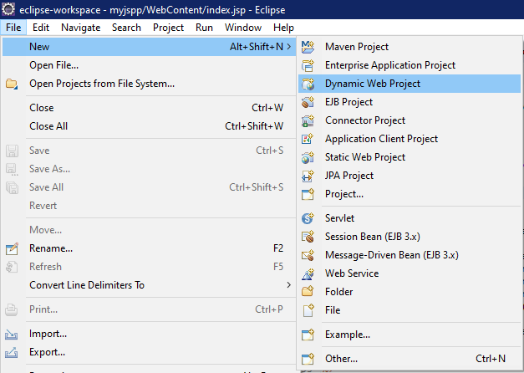

Then write project name (for e.g.:- webbaapp) and click **Finish*.***

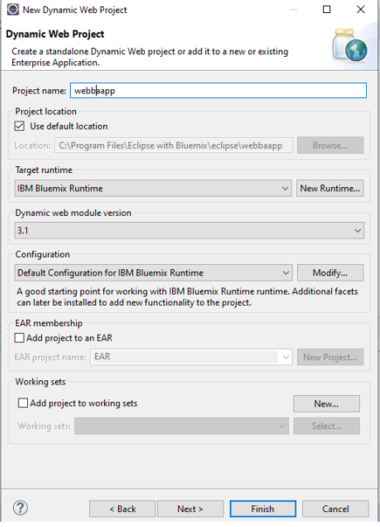

B) After creating the project, right click on the project and select a new jsp file with the name **“index. jsp”.**

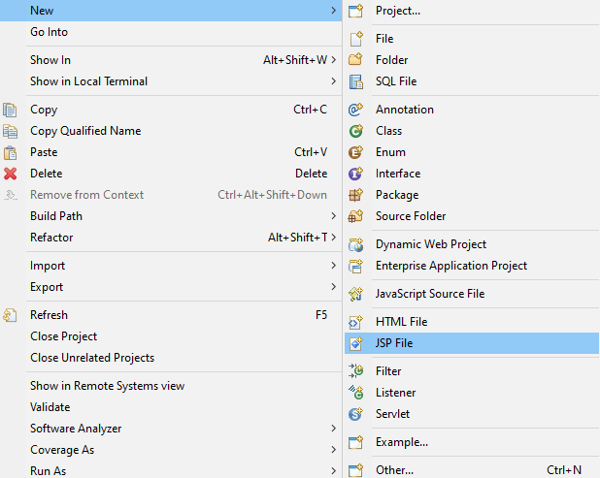

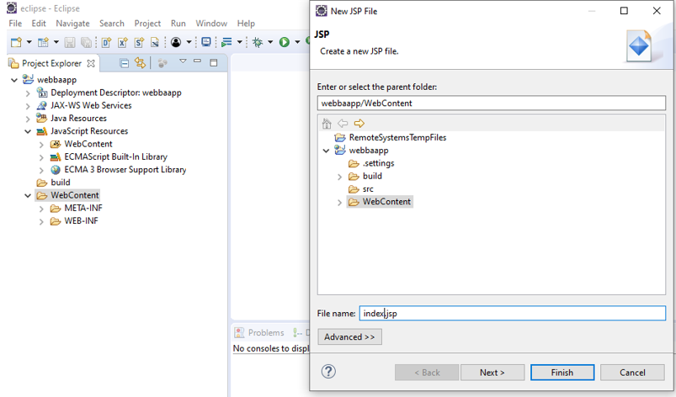

C) And write down the code using file Name **“index. jsp”**

<%@ page language=*"java"* contentType9=*"text/html; charset=ISO-8859-1"*

pageEncoding=*"ISO-8859-1"* import=*"java.sql.*"*%>

<!DOCTYPE html>

<html>

<head>

<meta charset=*"ISO-8859-1"*>

<title>Trip</title>

<style>

**body**

{

background-image:*url("download (1).jpg")*;

background-repeat: *no-repeat*;

width:*99%*;

background-size: *cover*;

}

*.header*

{

width:*85%*;

height: *60px*;

background: *white*;

margin:*70px 0px 0px 100px*;

}

*.head1*

{

height:*90px*;

width:*100px*;

float:*left*;

margin:*0px 0px 0px 100px*;

}

*.head2*

{

float: *right*;

display: *inline-flex*;

margin: *0px 30px 0px 0px*;

color: *black*;

}

*.head2* **ul**

{

list-style: *none*;

display:*inline-flex*;

}

*.head2* **ul** **li**

{

margin:*0px 20px 10px 0px* ;

padding:*7px*;

}

*.head2* **a**

{

text-decoration: *none*;

font-size: *25px*;

color:*blue*;

}

*.middle*

{

width:*30%*;

float: *left*;

}

*.middle* **p**

{

color: *white*;

font-size: *60px*;

}

*.content*

{

width: *350px*;

height: *580px*;

position: *relative*;

margin: *10px 0px 0px 700px*;

background: *linear-gradient(to top,blue,white)*;

opacity: *0.9*;

padding: *5px*;

margin-top: *100px*;

}

**h2**

{

font-family: *Arial*;

text-align: *center*;

}

**hr**

{

width: *50%*;

}

*.con*

{

top:*110px*;

transition: *6s*;

margin-left: *40px*;

font-size: *20px*;

}

**form** **label**

{

font-weight: *normal*;

display: *table-cell*;

vertical-align: *middle*;

font-size: *17px*;

text-transform: *uppercase*;

letter-spacing: *.15em*;

display: *block*;

margin-bottom: *10px*;

}

**input**[type=text]**,** **input**[type=date]

{

width: *80%*;

padding: *8px*;

margin: *5px 0 10px 0*;

display: *inline-block*;

border: *none*;

background: *#f1f1f1*;

}

**select**

{

width: *85%*;

padding: *8px*;

margin: *5px 0 10px 0*;

display: *inline-block*;

border: *none*;

background: *#f1f1f1*;

}

**button**

{

background-color: *darkblue*;

color: *white*;

padding: *14px 20px*;

margin: *8px 0*;

border: *none*;

cursor: *pointer*;

width: *85%*;

opacity: *0.9*;

font-size: *18px*;

}

**button***:hover*

{

opacity:*5*;

}

</style>

</head>

<body>

<div class=*"header"*>

</div>

<div class=*"middle"*>

<h1>Planing Trip To Anywhere in The Country?</h1>

</div>

<div class=*"content"*>

<h2>Book Your Trip</h2>

<hr><br>

<form action=*"#"*>

<div class=*"con"*>

<label for=*"fullname"*>Your Name</label>

<input type=*"text"* name=*"fulln"* class=*"form-control"*>

</div>

<div class=*"con"*>

<label for=*"activities"*>Activities</label>

<select name=*"#"* name=*"acti"* class=*"form-control"*>

<option value=*""*>Hiking</option>

<option value=*""*>Caving</option>

<option value=*""*>Swimming</option>

<option value=*""*>Skydiving</option>

</select>

</div>

<div class=*"con"*>

<label for=*"destination"*>Destination</label>

<select name=*"#"* name=*"dest"* class=*"form-control"*>

<option value=*""*>Himachal Pradesh</option>

<option value=*""*>Karnataka</option>

<option value=*""*>Jammu & Kasmir</option>

<option value=*""*>Goa</option>

<option value=*""*>Maharashtra</option>

</select>

</div>

<div class=*"con"*>

<label for=*"date-start"*>Date Travel</label>

<input type=*"date"* name=*"date"* class=*"form-control"*>

</div>

<div class=*"con"*>

<button type=*"submit"* name=*"btn"* value=*"SUBMIT"*>SUBMIT</button>

</div>

</form>

</div>

<%

**if**("SUBMIT".equals(request.getParameter("btn")))

{

String fullname=request.getParameter("fulln");

String activities =request.getParameter("acti");

String destination=request.getParameter("dest");

String date=request.getParameter("date");

System.out.println("Hello "+fullname+" your activities is "+activities+", Your Designation is "+destination+" and Your date is "+date);

}

%>

</body>

</html>

**Step: 2- Adding Files & Servers**

A) Next **“mysql-connector-java”** file paste into **“lib”** folder for connection

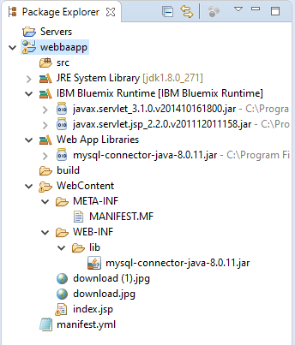

B) Next we have to go webbaapp and right click on **Run as**and then click **“Run on Server”**

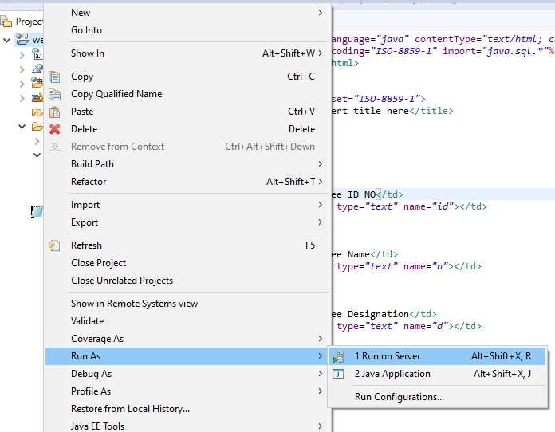

C) Now we have to select **“IBM Blumix”** and click on next

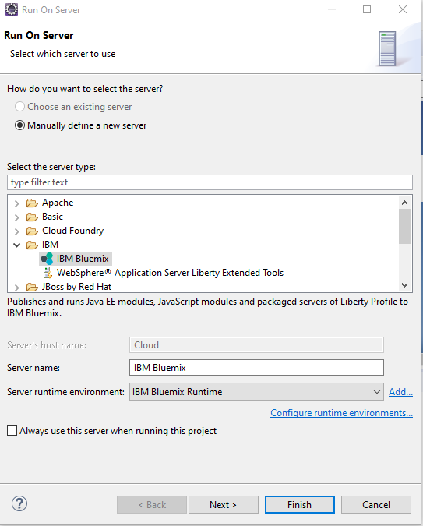

D) Now we have to put Email & Password and select **“Manage cloud”** then click **“Validate Account”** then click **“next”.**

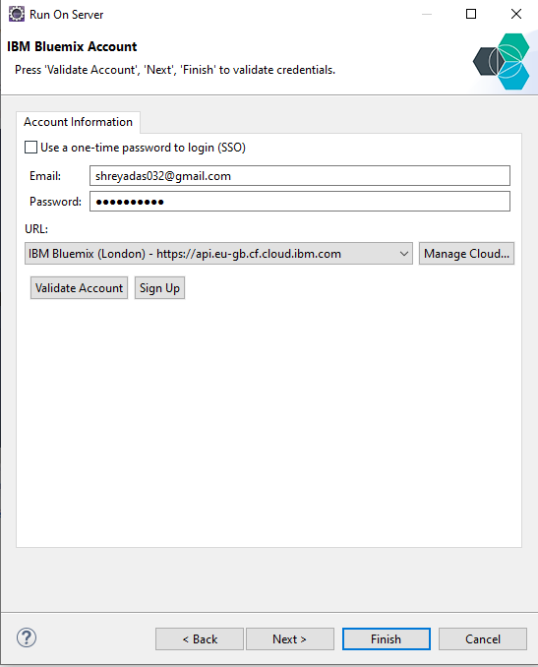

E) Click next.

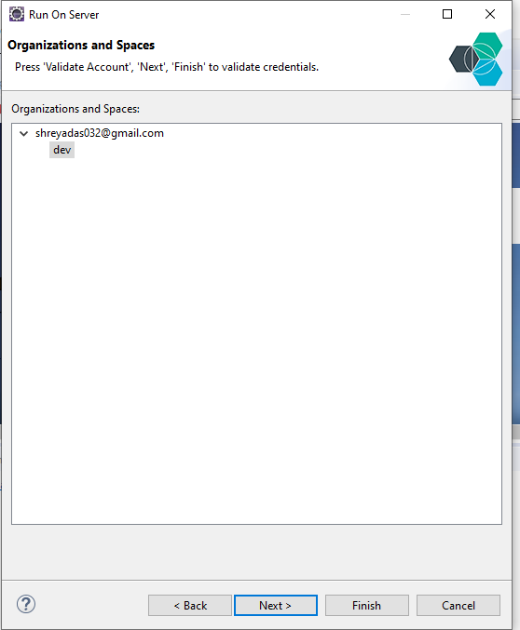

F) Then click **“Add**” and click **“Finish”**

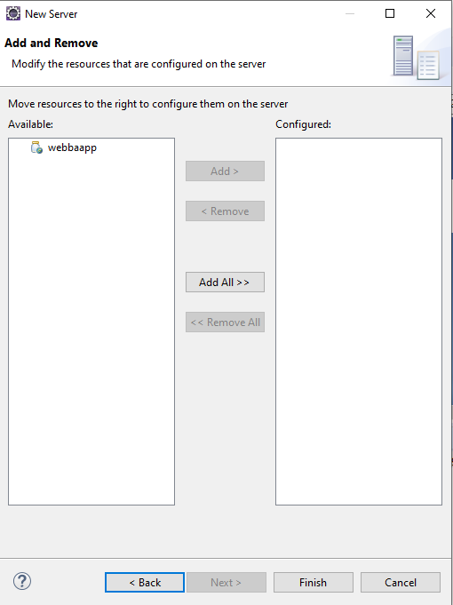

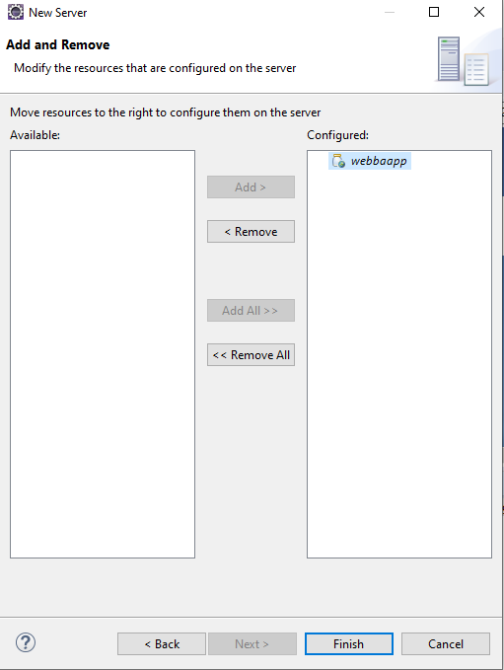

G) We have to create **mainifest.yml** and click next.

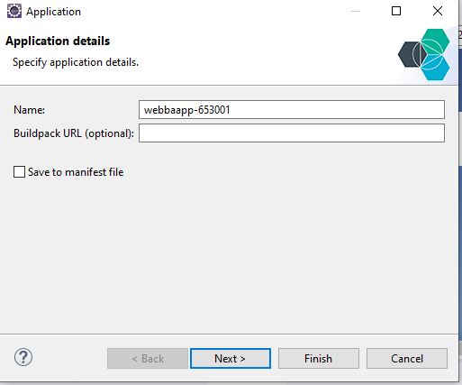

H) We have to put “**Memory Limit (256)”** then click next.

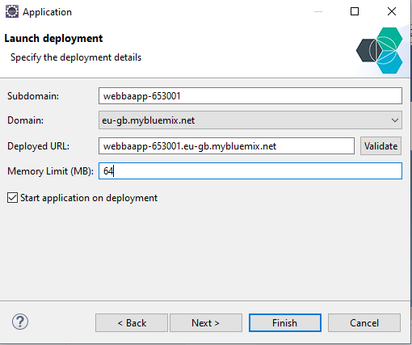

I) Click next.

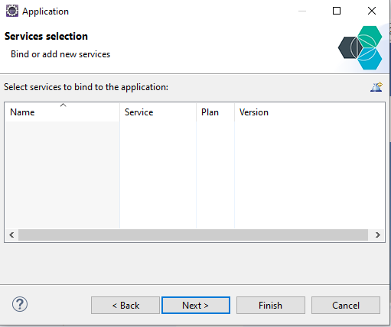

J) Then click finish.

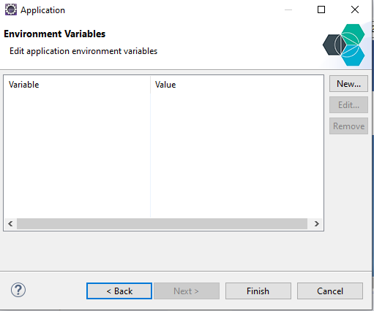

k) We have create “ **Server”.**

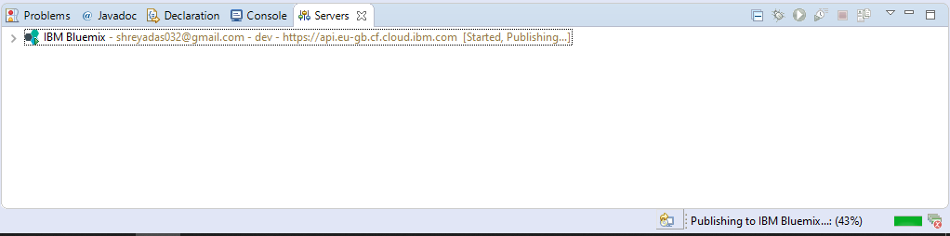

L) Application successfully pushed in **“IBM Bluemix”.**

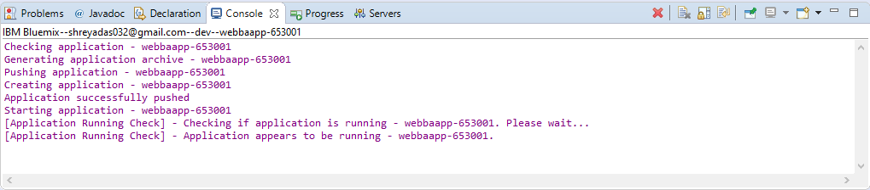

M) Progress in launching.

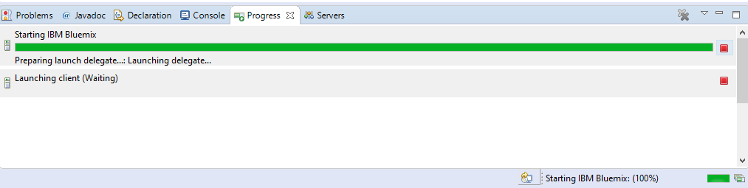

**Step: 3- Deploy in IBM Cloud**

A) Login in **“IBM Cloud”.**

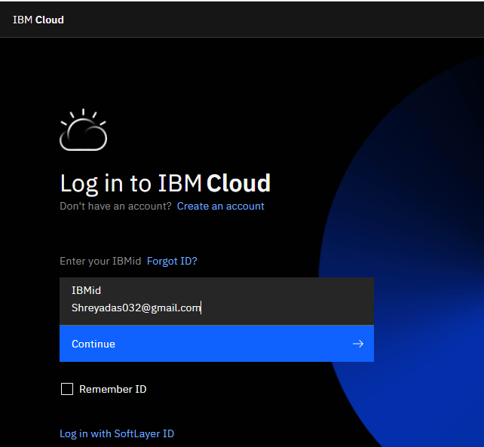

B) Open **“Resource list”** and click on **“Cloud Foundry apps”** then double click on **“ webbaapp-653001”.**

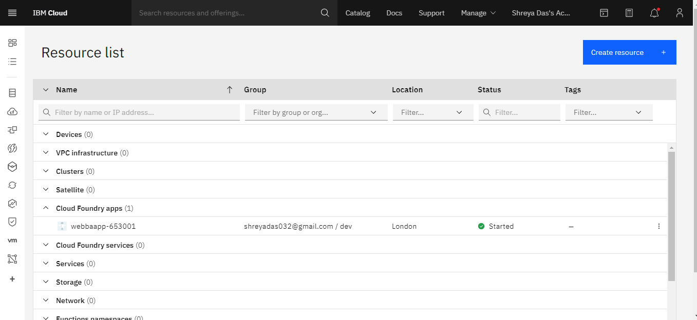

C) Click on **“ Visit App URL “.**

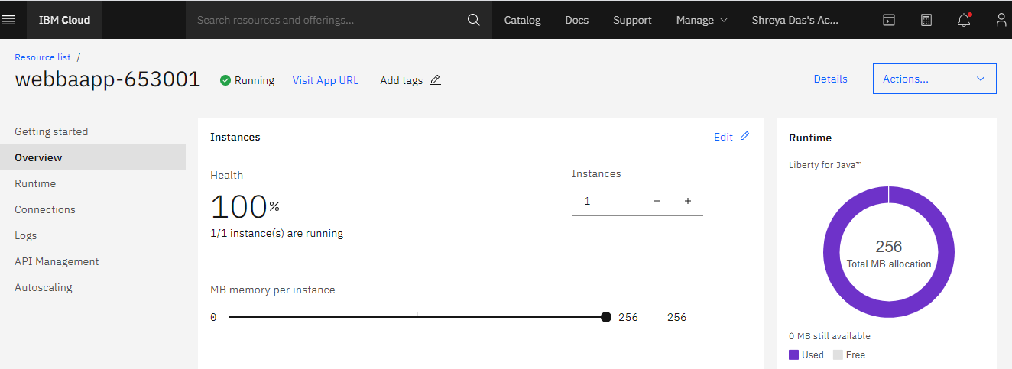

**Output**

**Step:4 – Getting Output**



**Conclusions**

Eclipse makes a great local development environment for developing and deploying Java EE applications to Bluemix. This the whole process where I have described in the documentation how I made a web application using jsp /java with the Eclipse, MySQL in the IBM Bluemix.

**REFERENCES**

1. <https://dev.mysql.com/downloads/installer/>

2. <https://www.sitepoint.com/top-5-paas-solutions-developing-java-applications/>

3. <https://cloud.ibm.com/login>

**THANK YOU**